SUM and COUNT

1. SELECT SUM(population) FROM world

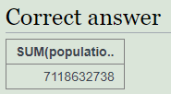

1. select distinct(continent) from world

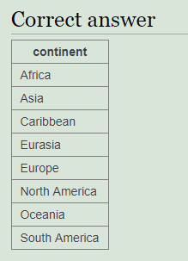

1. select sum(gdp) from world where continent = 'Africa'

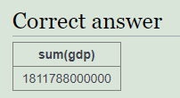

1. select count(name) from world where area >= 1000000

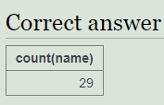

1. select sum(population) from world where name in ('Estonia', 'Latvia', 'Lithuania'

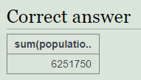

1. select continent, count(name) from world group by continent

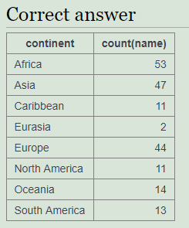

1. select continent, count(name) from world where population >= 10000000 group by continent

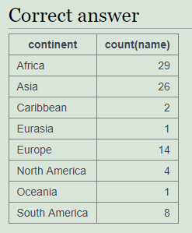

1. select continent from world group by continent having sum(population) >= 100000000

